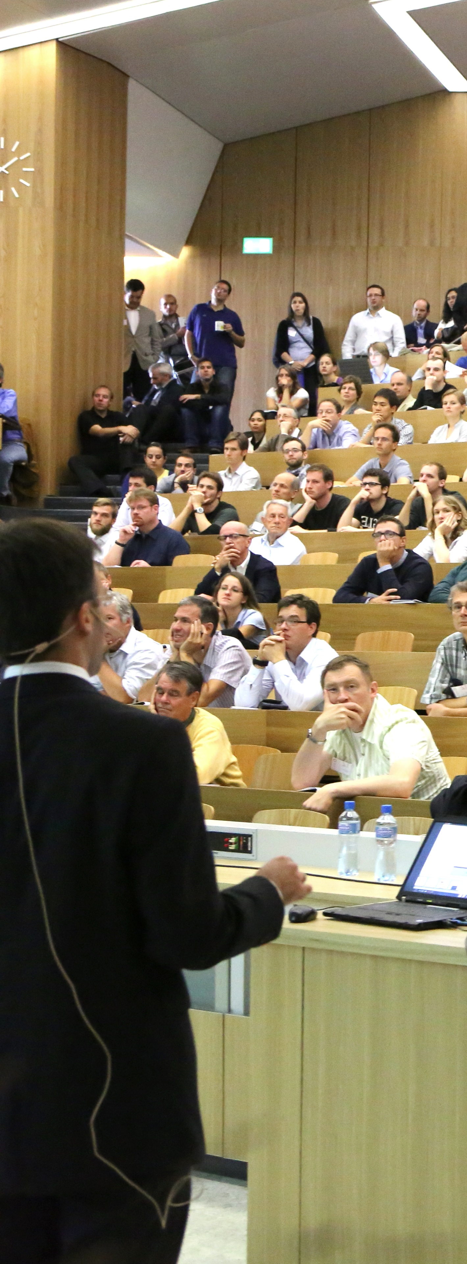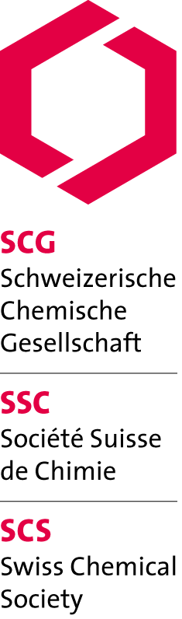

SCS Lectureships 2013

Prof. John Caradonna

Boston University (USA)

«Mechanism of action of non-heme iron metalloproteins, with a focus on the chemistry of metalloenzyme active sites involved in biological oxidation reactions»

*Mon, 17.06.13, 16:15*

University of Zurich, Anorganisch-chemisches Institut

Hörsaal 19, Winterthurerstr. 190, Uni Zürich Irchel'

http://www.scg.ch/scs-lectureships/

Supported by:

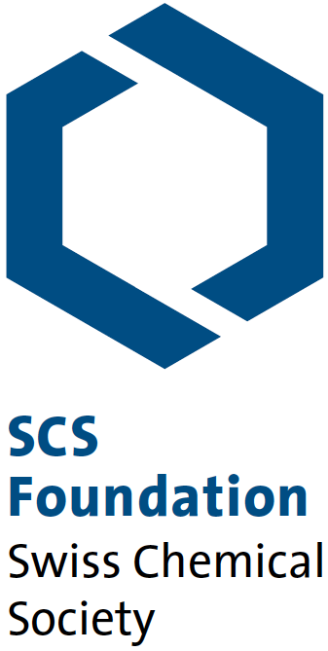

Swiss Chemical Society

Schwarztorstrasse 9

3007 Bern

www.scg.ch